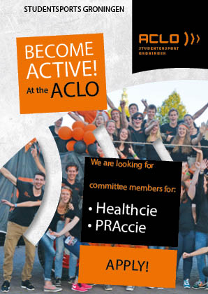
Index
Become an active member of the ACLO! 3
The ACLO and the Healthcie 4
The Health committee (Healthcie) 5
About the ACLO 8
What does the ACLO offer? 9
ACLO structure 11
Apply now! 12

Become an active member of the ACLO!

The ACLO gives you the opportunity to join one of the many committees. You can develop yourself on a personal level during a committee year and it is a fun way to meet new people. Besides that it also looks good on your resume!
Would you like to join a committee of the largest student sport organization of Europe? Are you interested in a healthy lifestyle and do you want to make other students aware of its importance? Then our health committee (Healthcie) is looking for you! The Healthcie is responsible for organizing two healthweeks and giving the Daily Board of the ACLO input about Healthy Ageing.
Are you interested? Send your motivation letter and your resume to coordinatorintern@aclosport.nl

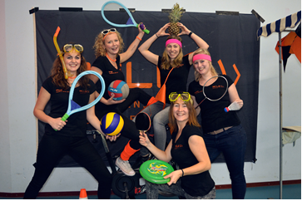

The ACLO and the Healthcie

The ACLO gives students of the RUG and the Hanzehogeschool the opportunity to try out a lot of sports. We do this by offering varied and accessible sports: think of the many courses, group lessons and open hours. The ACLO also wants to fulfill a social function by providing a recognizable social environment: when you play sports at the ACLO, you sport with people like you: students.
Health is in taking an ever-increasing place in society: the younger generations have a longer life expectancy. A healthy lifestyle with good nutrition and sufficient movement contributes to this. The government tries to make everyone as healthy as possible through campaigns and projects. Sports is an important part of these campaigns and projects. The RUG, the HG, the UMCG and the municipality of Groningen work together at a local level in the Healthy Ageing project.
The ACLO a mission to get as many students as possible students to go and exercise and to make students aware of Healthy Ageing. This is where the Healthcie gives the ACLO a helping hand.

The Health committee (Healthcie)

As a member of the Healthcie, you get a lot of space to use your creativity: think of new activities to promote Healthy Ageing among students! In the past years, the Daily Board of the ACLO has tried a number of activities and made a guide for the Healthcie. As Healthcie you can use this guide to find out what the ACLO already does when it comes to Healthy Ageing and to get an impression of what is possible. In addition to existing activities you, as a committee, are free to organize some extra activities. The possibilities are endless!
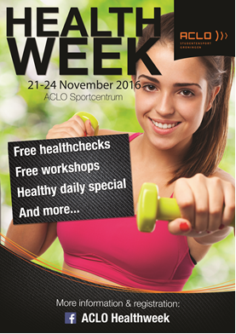
Examples of the tasks of the Healthcie are:
- Organizing Healthchecks and activities to promote Healthy Ageing. You can think of a secondary program during the existing ACLO events, such as KISS or Sportplaza in the KEI week, as well as Healthy Ageing events, such as the Healthweek. You can find all the events of the ACLO at page 9.
- Maintaining contact with various professionals, such as physiotherapists or dieticians to obtain information that can be posted on the Healthy Ageing page of the ACLO website.
- Keeping the Healthy Ageing page on the website up-to-date.
- Providing information about Healthy Ageing at the Sportcentre. For example by making flyers, posters, or posting fun facts about a healthy lifestyle on the ACLO Facebook page.
- Organize ludic actions and challenges to create more awareness about Healthy Ageing amongst students.
Teamwork
You will work with other motivated students to organize fun activities that promote Healthy Ageing. This is of course very awesome! To make these events to a success, it's very important that you work together as a team. Skills such as communicating, collaborating, planning and being creative are therefore important when you are in a committee. You organize fun events with peers who share the same interests and who are just as motivated as you are!
Communication
As a Healthcie member, you can provide the students with a lot of information about Healthy Ageing. It is very important that you provide valid information about a healthy lifestyle! Therefore, you will have a lot of contact with Healthy Ageing professionals: physiotherapists, dieticians, contact persons in sports and health studies or even sports psychologists. This is a great opportunity to get to know a lot of new people and to make connections that could be helpful for you after you finished your study!

Fun
The ACLO organizes many fun activities for all committee members and boards. For example; we plan some sports activities, have a drink together, join a pubquiz or have diner together. Because of these activities you don’t only have contact with your own committee, but also with the other ACLO committees!

Time to spend
When you become a member of the Healthcie, you are in the committee for a whole year. When you have the ambition to stay longer in the committee, then this is of course possible. The committee year of the Healthcie starts in March.

You’ll discuss with your committee when you meet each other. It depends how much time you spend on your committee work. Just before the event, you will be more busy than average.

Functions of the Healthcie
Within the Healthcie there are several functions. There is one chairman. He / she is responsible for the work provided by the committee members and he/ she is also the person who contacts the Daily Board of the ACLO. The other functions will be divided among the other members of the committee. This ensures that you have many different aspects within the committee, such as promotion, sponsorship or materials.

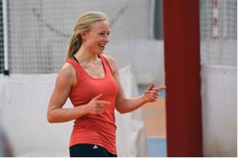
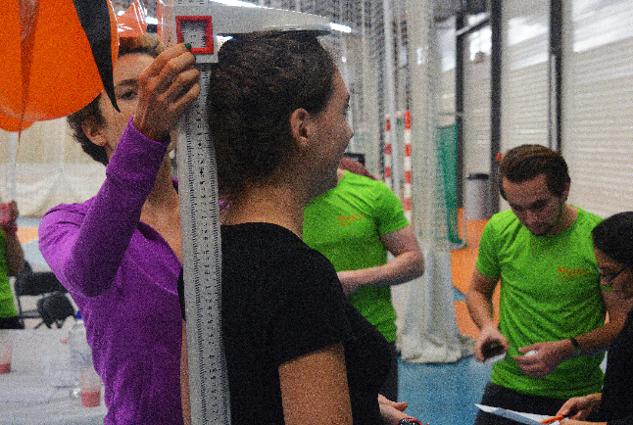
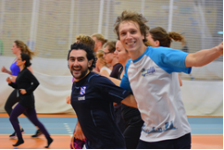

About the ACLO

The ACLO is the overarching student sports organization of the University of Groningen and the Hanze university of applied sciences and for the 49 sports clubs of the ACLO. For the students of both organizations the ACLO offer sports in many different ways.

The ACLO was founded in 1945 and is the largest overarching student sport organization of the Netherlands. The ACLO represents the student sport of Groningen on a national level. At this moment nearly 18.000 students sport at the ACLO for only €59,95 a year. The ACLO is there for the most important supplier of sports for students in Groningen.

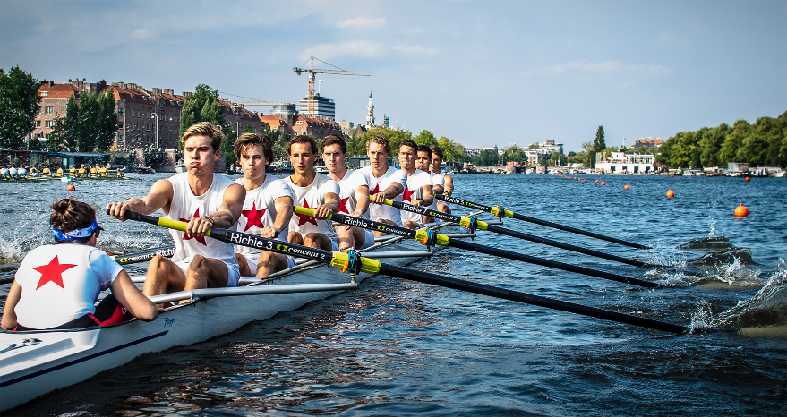

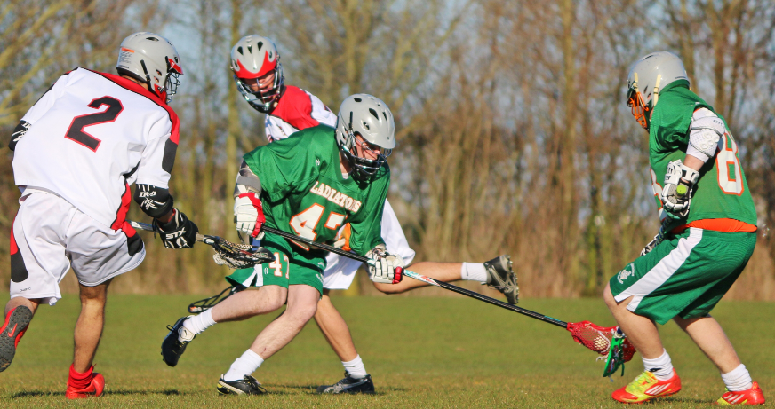
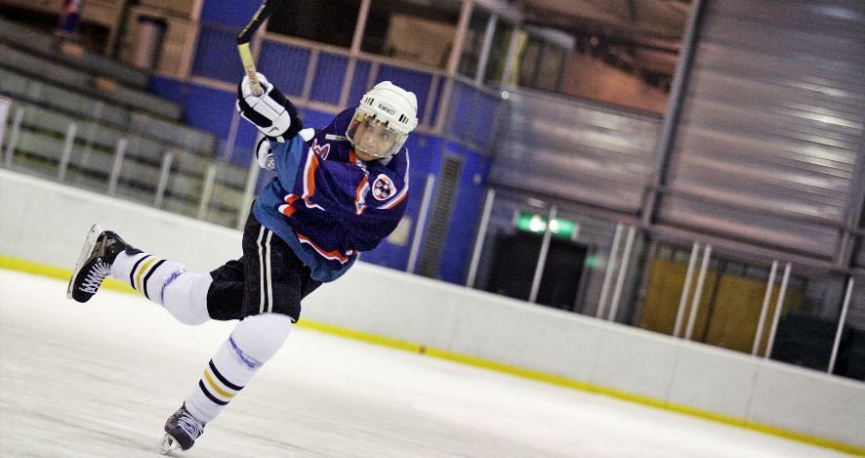

What does the ACLO offer?
Free reservations:
ACLO-members have the opportunity to book a hall, court or field at the ACLO Sports Centre.

Group lessons and open hours:
Group lessons and open hours are given throughout the year and are in most cases accompanied by a sports coach. There are about 20 group lessons or open hours scheduled each day. You don’t need to register in advance at the Zernike location. Participation is entirely voluntarily and you can work out at your own level. In the WAS and at ACLO Station you must reserve a ticket before you join a group lesson or open hour. Examples of group lessons and open hours are: bodyfit, swimming, soccer, spinning, circuit training and aquarobics.

Courses:
The ACLO offers the ACLO-members free five- and ten-week courses. After the course they will know the basics of the sport in question and be able to play the sport on their own. Examples of courses taught at the ACLO are: water skiing, golf, gliding, tennis, football, dance, shooting, skydiving and karate.

Sports Associations:
Besides the group lessons, open hours, courses and free reservations it is possible for an ACLO-member to join one of the sport associations. There are 49 different sport associations affiliated to the ACLO.

Events:
The ACLO organizes several events during the year for her (potential) members like:
- The ACLO-Vitalisloop:
The ACLO-Vitalisloop is an open running contest which is organized in collaboration with the association G.S.A.V. Vitalis. The contest is organized twice a year; once in preparation for the 4 Miles of Groningen and once in preparation for the Batavierenrace.

- The ACLO-Sportsgala
The gala committee (Galacie) organizes the ACLO-Sportsgala in February. During this gala the winners of the Sports prize election will be announced.

- Board/ committee activities
During the year there are various activities and get-togethers organized for the active members of the ACLO (committee members and the ACLO boards).

- ‘Athenespelen’
This is a sports days for students who are in the final stage of their secondary school.

- ‘Bestuursspelen’
The PR & Activity committee (PRAccie) organizes in May/June the ‘Bestuursspelen’ at the ACLO. This is a tournament for all the boards of the sports associations.

- ESN meets ACLO:
This is a sports day which is held twice a year for the international students in Groningen. The purpose of this event is that international students get to know the ACLO. The event takes place during the introductionweek of ESN.

- Healthweek
Annually the Health committee (Healthcie) organizes two weeks that are completely dedicated to Healthy Ageing: the Healthweeks. During these weeks we will pay attention to the various aspects of a healthy lifestyle, ranging from nutrition, sports and exercise to mental health.

- ‘Kaderdag’
The PR & Activity committee (PRAccie) organizes the ‘Kaderdag’ in November. During this day the boards of the associations are getting some workshops and lectures.
- KEI-week
The ACLO is present at 3 activities during the KEI-week.
- Information market: this information market takes place on the 1st day of the KEI-week and is intended to give the ‘KEI-lopers’ an idea of what they can do in Groningen.
- Sportplaza: during the KEI-week there is a sports market organized at the ACLO. The KEI-lopers are getting there first impression of the ACLO this day.
- KEI-Parade: this is a parade through the city center of Groningen.

- KISS
The purpose of this event is to introduce non ACLO-members to the ACLO. It's a big sports day with various tournaments, workshops and open hours where students can participate.

These are all ACLO events. The Healthcie isn’t involved with all of them.

ACLO structure

General Board of the ACLO:
The General Board is the institution that controls the Daily Board. Every year the General Board consists of 11 students who have meetings at least seven times a year. They have a voice in important issues concerning the ACLO and control its long term policy.

Daily Board of the ACLO:
The Daily board is a full time board and are concerned with the daily affairs of the ACLO. The Daily Board is, among other things, responsible for the sports offer and sports time table, the distribution of grants and the representation of the Groningen student sports in Groningen and on a national level.

Committees of the ACLO:
The ACLO is an organization for and by students. Besides the Daily and General Board there are several committees who organize events, do promotional activities and so on. All of these committees have their own tasks and responsibilities. The committees of the ACLO are: The ACLO-Mediateam, PR & Activity committee (PRAccie), Health committee (Healthcie), Sportcie, Galacie, Cocie and the ACLO-Denktank.
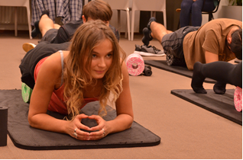

Apply now!

Have you become excited about the ACLO? Do you want to work with four fellow students for a year and make others excited about the ACLO? Do you want to make students aware of Healthy Ageing? Or do you want to gain experience by becoming active in a committee? Apply now for the Healthcie!
Data
t/m 11 februari 2018: send your resume and motivation letter to coordinatorintern@aclosport.nl.
Februari 2018: Interviews with the applicants at the ACLO.
End februari 2017 Announcement new Healthcie
End februari – begin March Instruction sessions (date and time will be announced as soon as possible).

